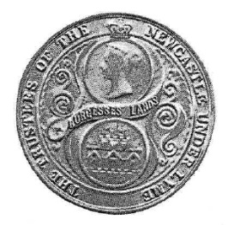
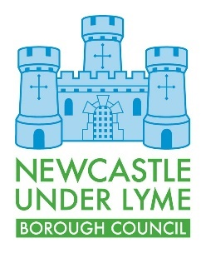

BURGESS ADMISSION FORM

(Burgess Lands Act 1859)

Surname:
(if applicable maiden name):
First name(s):
Address:
Telephone Number:
Email Address:
Occupation:
Date of Birth:
If claim is by birth as parent is a Burgess, give parent’s
- Full name
- DOB
- Occupation
- Admission Date (if known)

(Provide family name of admission if different from above)
If claim is by birth as Grandparent is a Burgess, give Grandparent’s
- Full name
- DOB
- Occupation
- Admission Date (if known)

(Provide family name of admission if different from above)

Evidence must be provided in support of your application (see Page 2)

(please tick as appropriate)
By birth – parent is a Burgess:
My full birth certificate showing my parent’s name
(if parents name not shown then must also provide parents birth certificate)
By birth – paternal grandparent is a Burgess:
My full birth certificate showing my parent’s name
My father’s full birth certificate showing my paternal grandparents name
By birth – maternal grandparent is a Burgess:
My full birth certificate showing my parent’s name
My mother’s full birth certificate showing my maternal grandparent’s name
My mother’s marriage certificate which demonstrates a change of name

Note: You can provide a copy or photograph of the birth certificate(s), we do not need the original

Newcastle under Lyme Borough Council will hold and process the information you supply in accordance with data protection legislation. We will use the information provided to allow us to process your application for membership to the Burgesses Guild. As part of this process, we do share your information with the Newcastle-under-Lyme Burgesses Guild Council.
For further information about how we process personal information please visit Data protection and freedom of information – Newcastle-under-Lyme Borough Council

Date: _________________ Signature: _________________________________

Please return your completed application along with the relevant documentation to
burgessesadmin@newcastle-staffs.gov.uk
or
Burgess Admissions, Newcastle-under-Lyme Borough Council, Castle House,
Barracks Road, Newcastle-under-Lyme, Staffordshire, ST5 1BL

Office Admin Only
Information Checked by NULBC and confirmed accurate.

Date: __________________

Signature: __________________________

